CE301 Capstone Project

Project Abstract/Overview

Output current loop sensors are industrial devices that transmit measured data such as pressure, temperature, position, etc by regulating current in a series loop (typically between 4 – 20 mA). The goal of this project is to design a real-time live-testing device that measures and displays artificial sensor readings using company specific user-programmable hardware which simulates the hardware states of such industrial sensors, all following the same standard.

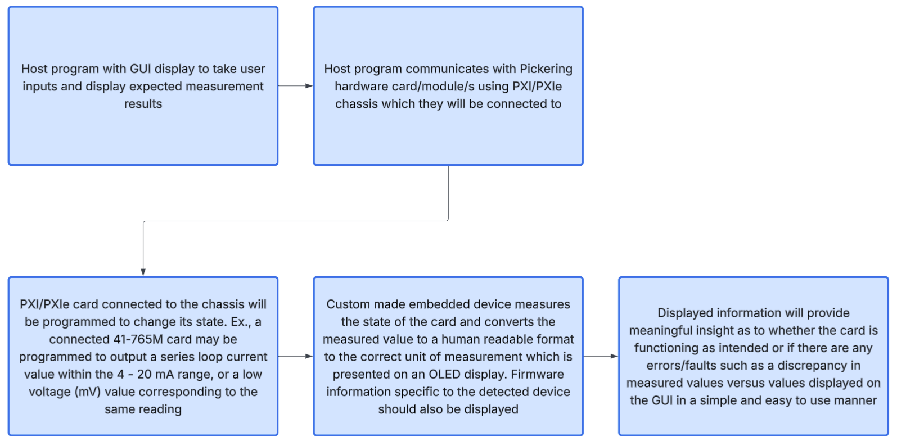

Tested Card Information

The system must be compatible with the following simulation card type (company customer product card):
- 41-765M Analogue Output/Current Loop Simulator Module – Different variants of this module are available in four forms each consisting of 16, 12, 8, or 4 channels.

Simulates a sensor which sources or sinks currents between the 4 to 20 mA Current Loop communication range used in industrial automation. The 41-765M card also includes other modes of operation which will be incorporated into the system for the user to set.

Other types of simulator cards which may be incorporated within the project timeline:
- Programmable Resistor Cards
- Resistance-based Temperature Simulators
- LVDT/RVDT/High Speed Resolver Simulators
- Cards which simulate a Resistive Load
- Strain Gauge Simulators

All cards will be slotted into a chassis which supports both PXI and PXIe card types to enable communication between host and cards under test.

System Functionality Overview

The system will consist of two major parts which are:
- The host program which takes simulation readings set by the user using a GUI. These expected/theoretical sensor readings will be then displayed on the same GUI. The host program will be programmed using a language such as C# or Python.

The host program will use company proprietary APIs to serially communicate to the currently selected card under test and program the card to change its current state by setting voltage/current output values of the 41-765M card, adjusting the resistance across a specified channel of a programmable resistor card, etc.

- The programmed card states will be transmitted to a physical embedded device which will be able to detect which card types are being tested, or at the bare minimum acquire a control panel system option to select which card types are being used for measurement.

The device will measure the programmed physical states of the card and display them on an OLED screen serving as a real-time testing system by checking the initial response of the card/s and whether the measured values match what is displayed on the GUI.

This device will consist of programmable hardware (programmed in C or C++), an OLED and a control panel as peripherals, and electronics to power the device. Additional modules and/or designed electronic hardware will also be implemented in conjunction with the microcontroller if necessary.

The embedded program will need to use an onboard ADC (or other external module/circuitry) to convert analogue readings into digital form. These values will be read by the microcontroller and converted into base 10 numerical form of the correct unit of measurement, ex. 4.5 Pa for pressure, or 10°C for temperature. There will be options for the user to select which type of sensor reading is to be obtained by the user.

